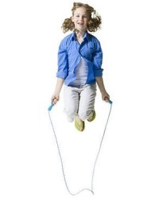joggingweight trainingwalking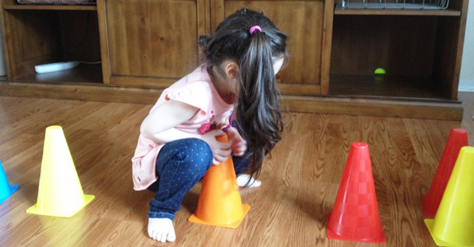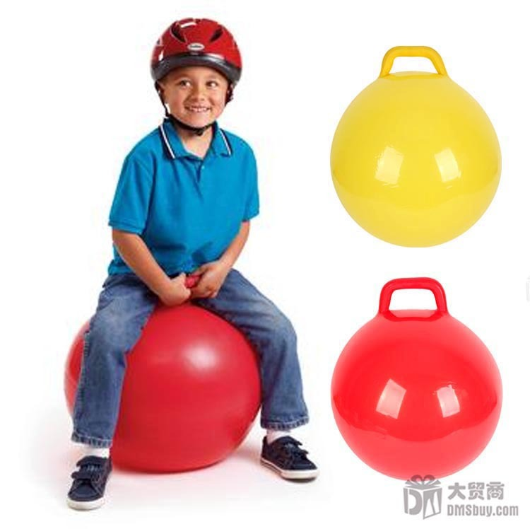

Scottsbluff

National Monument

190276 Old Oregon Trail Rd.

Gering, NE

(308) 436-9700

Scottsbluff

Splash Arena Pool

2813 2nd Ave

Scottsbluff, NE

(308) 630-6240

Westmoor Pool

1936 Ave I

Scottsbluff, NE

(308) 632-8881

Wildcat Hills

State Recreation Area

210615 Hwy 71

Gering, NE

(308) 436-3777

YMCA

1918 S Beltline Hwy W

Scottsbluff, NE

(308) 632-5705

Carpenter Center

116 Terry Blvd

Gering, NE

(308) 635-8422

Parks

1600 S Beltline Hwy W

Scottsbluff, NE

(308) 630-6238

1818 Avenue A

Scottsbluff, NE

(308) 630-6238

2525 Circle Dr.

Scottsbluff, NE

(308) 632-0059

Playhouse

775 Crescent Dr.

Gering, NE

(308) 632-5996

Riverside Zoo

1600 S Beltline Hwy W

Scottsbluff, NE

(308) 630-6236

## Local Resources

## Ben Garcia, Erin Kuhn,

## Lauren Reiber, Nick Majernik,

## and Samantha Haun

I, _________________ accept the challenge of increasing my physical activity until I reach the goal of 60 minutes each day. This will help me become healthy, give me more focus in the classroom, and have more fun!

I am committed to Keeping Kids Active!

_______________________ ____________

Child’s Signature Date

_______________________ ____________

Parent’s Signature Date

## I accept

## the Challenge…

#### Keeping Kids Active

UNMC College of Nursing – Scottsbluff Campus

1601 E. 27th St  
Scottsbluff, NE 69361

(308) 632-0413

##### Keeping Kids Active

###### Keeping Kids Active

###### Committed to

###### Children and adolescents should do

###### 60 minutes (1 hour) or more of

###### physical activity each day

##### **Keeping Kids Active**

### Long-term Health Effects:

* Children and adolescents who are obese are likely to be obese as adults and are therefore more at risk for adult health problems such as heart disease, type 2 diabetes, stroke, several types of cancer, and osteoarthritis.  One study showed that children who became obese as early as age 2 were more likely to be obese as adults.
* Overweight and obesity are associated with increased risk for many types of cancer, including cancer of the breast, colon, endometrium, esophagus, kidney, pancreas, gall bladder, thyroid, ovary, cervix, and prostate, as well as multiple myeloma and Hodgkin’s lymphoma.
* Obese youth are more likely to have risk factors for cardiovascular disease, such as high cholesterol or high blood pressure. In a population-based sample of 5- to 17-year-olds, 70% of obese youth had at least one risk factor for cardiovascular disease.
* Obese adolescents are more likely to have pre-diabetes, a condition in which blood glucose levels indicate a high risk for development of diabetes.
* Children and adolescents who are obese are at greater risk for bone and joint problems, sleep apnea, and social and psychological problems such as stigmatization and poor self-esteem.

### Immediate Health Effects:

### 1. Aerobic Activity

Aerobic activity should make up most of your child's 60 or more minutes of physical activity each day. This can include either moderate-intensity aerobic activity, such as brisk walking, or vigorous-intensity activity, such as running. Be sure to include vigorous-intensity aerobic activity on at least 3 days per week.

### 2. Muscle Strengthening

Include muscle-strengthening activities, such as gymnastics or push-ups, at least 3 days per week as part of your child's 60 or more minutes.

### 3. Bone Strengthening

Include bone-strengthening activities, such as jumping rope or running, at least 3 days per week as part of your child's 60 or more minutes.